**Chapter 4 Network Layer**

4.1 Introduction Network Layer - transport segment from sending to receiving host

Two key network-`layer functions - Forwarding and Routing:

Forwarding: move packets from router input to output.

Routing: determine route by packets from source to dest.

routing algorithm determines end-end-path through network forwarding table determines local forwarding at specific router | 4.2 Virtual circuit and datagram networks

Datagram forwarding table: Bc billions of IP, rather than list individual destination address, list range of addresses, and use longest prefix matching to find specific IP

Longest prefix matching: When looking for the forwarding table entry for given destination address, use the longest address prefix that matches the destination address, aka the one that is the closest basically match w/ closest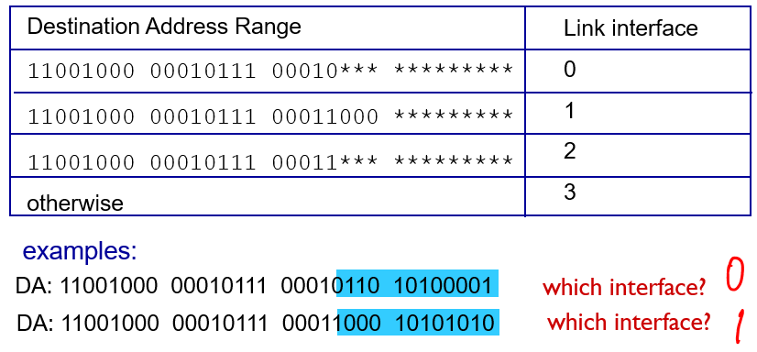

4.3 What’s inside a router two key router functions: run routing algorithms/protocol (OSPF, BGP) & forwarding datagrams from incoming to outgoing link

The architecture of a router: four main components: Input & output ports, routing processor, high speed switching fabric

Three types of switching fabrics: memory, bus, crossbar

scheduling: choose next packet to send on link - FIFO (first in first out) scheduling: send in order of arrival to queue

priority scheduling: high priority & low priority queues, if 2 come same time, send highest priority queued packet first 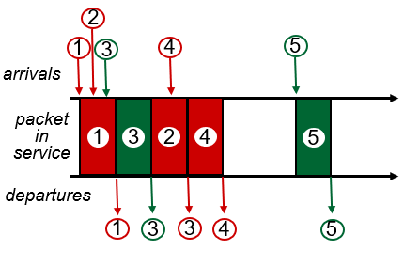

Round Robin (RR) scheduling: multiple classes,cyclically scan class queues, sending one complete packet from each class

Weighted Fair Queuing (WFQ): -> generalized Round Robin - each class gets weighted amount of service in each cycle - like a mix of RR & priority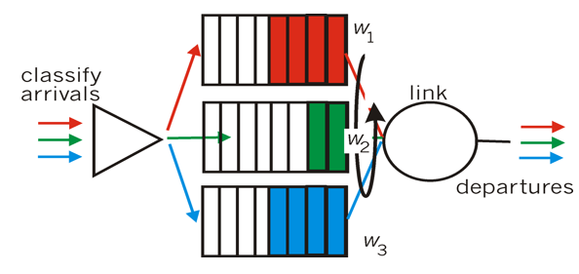

4.4 Internet protocol

IP datagram format 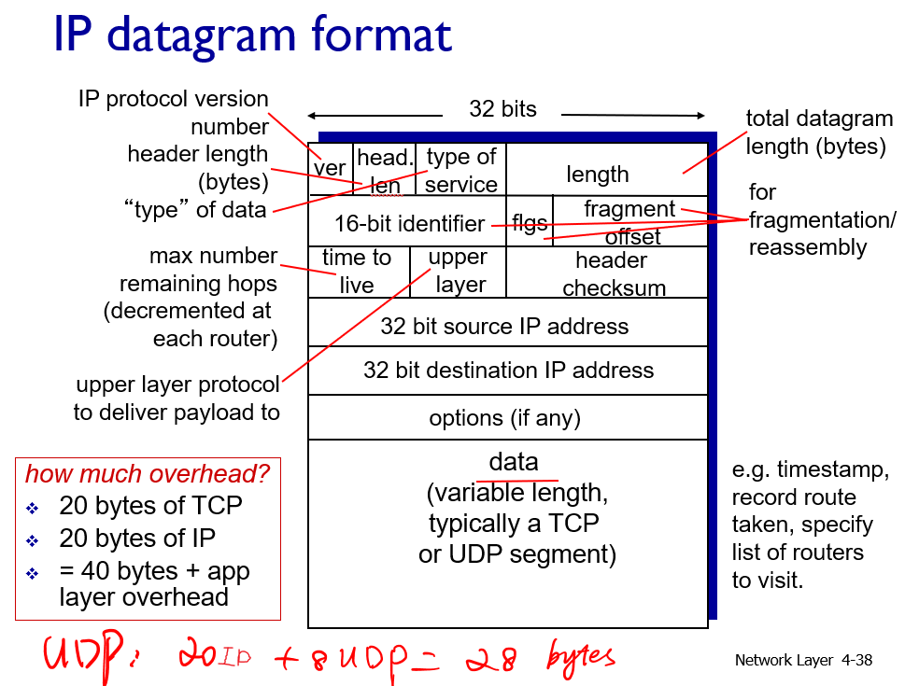

IP fragmentation:

network links have MTU (max.transfer size). To get datagrams to fit, need to fragmented large IP datagrams into several datagrams. “reassembled” only at final destination. IP header bits used to identify, order related fragments. **Orig Data** =*Dtgm – hdr* = 4000 – 20 =3980.

***Frg data*** = MTU – hdr = 1500 – 20= 1480.

***# of fragments*** = Orig Data/Frg Data= 3980/1480 = 3.

**Data in last frag(Leftover)** = 3980 -2x1480 = 1020

Offset has 8B bound. Thus **Offset #** = 1480/8 = 185. 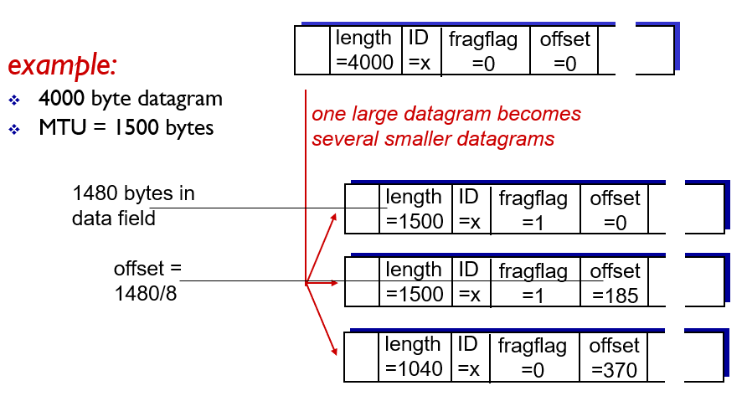

fragflag = 1, last fragflag = 0.

IPv4 addressing - IP address: 32-bit identifier for host, router interface, IP addresses associated with each interface. (usually broken into 4 8 bit parts, separated by a decimal, ex)223.1.1.1 ) Subnet - Devices that interface with same subnet part of IP address(Can physically reach each other without intervening router.)determine subnets by detaching each interface from host or router creating island of isolated networks.

CIDR: Classless Inter Domain Routing - address format: a.b.c.d/x, where x is # bits in subnet portion of address. Total # of bits is 32, find host by subtracting 32 - x. ex) given a subnet such as 138.65.89.0/22: 22 bits used to denote the subnet part, 10 bits to denote host. Up to 2^10 IP addresses.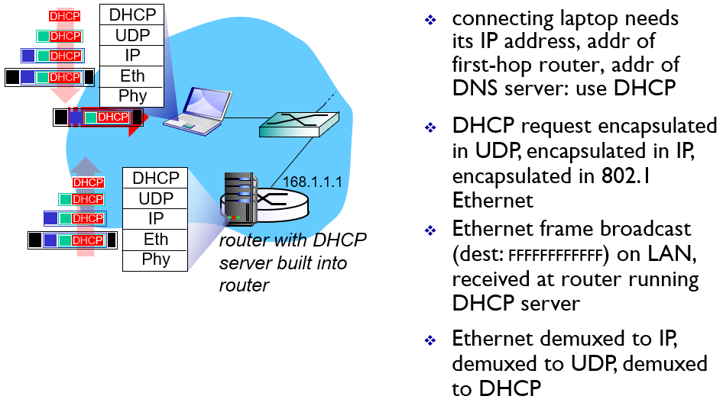

DHCP:Dynamic Host Configuration Protocol - allow host to dynamically obtain its IP address from network server when it joins network. Can ask for more than IP, could include address of first-hop router and IP address of DNS server, network mask. DHCP Steps to get IP:

1)host broadcasts “DHCP discover” msg [optional]

2) DHCP server responds with “DHCP offer” msg [optional]

3) host requests IP address: “DHCP request” msg 4) DHCP server sends address: “DHCP ack” msg

Hierarchical addressing - Allows for more efficient advertisement of routing 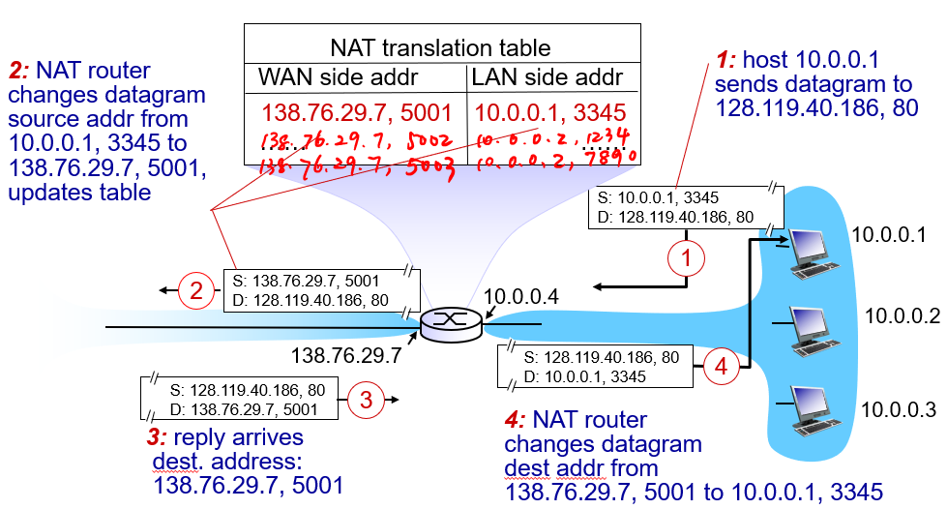

ex)from internet -> ip -> organization (“send me Send me anything with addresses

beginning w/ …. or …..)

NAT: network address translation all datagrams leaving local network have same single source NAT IP address ex)138.76.29.7, different source port numbers. Motivation: only need 1 IP for all devices, can change in side without notifying outside world, more secure ICMP IPv6: allows for longer IP addresses because 32 bit address space completely allocated soon.  
 IPv6 datagram format: 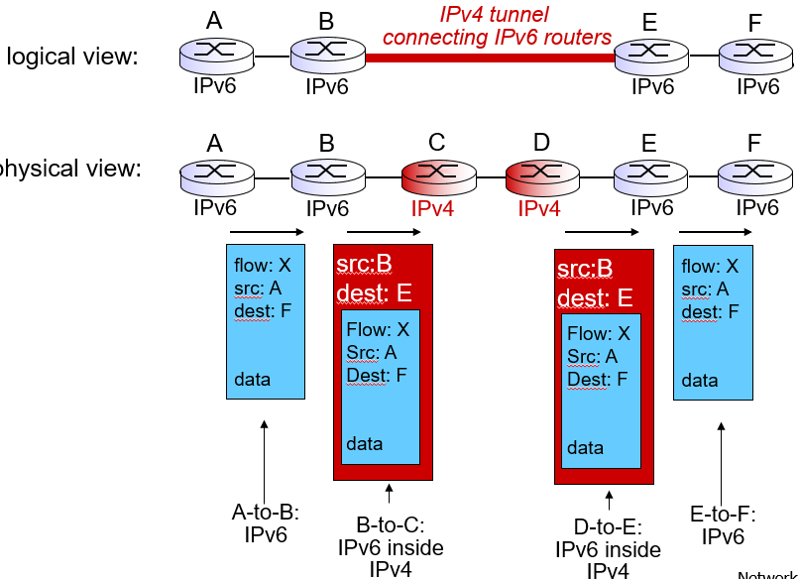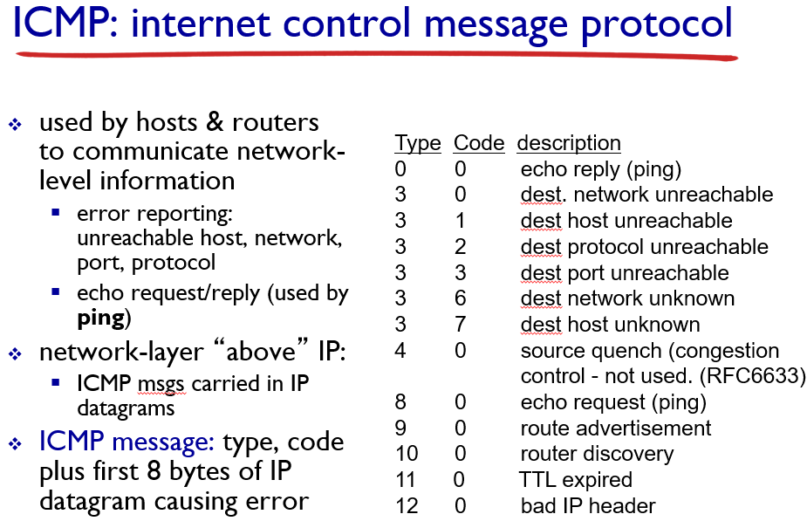

fixed-length 40 byte header

no fragmentation allowed tunneling: IPv6 datagram carried as payload in IPv4 datagram among IPv4 routers

4.5 Routing algorithm

link state algorithm/Dijkstra

c(x,y): link cost from node x to y; = ∞ if not direct neighbors

D(v): current value of cost of path from source to dest. v

p(v): predecessor node along path from source to v

N': set of nodes whose least cost path definitively known. Start with initial node in n’, DV chart at ∞. Replace DV with path if smaller than current path, include last node where came from. After you filled in all the DVs you can at that node, add shortest path to N’ and repeat w/ new node until all elements are in N’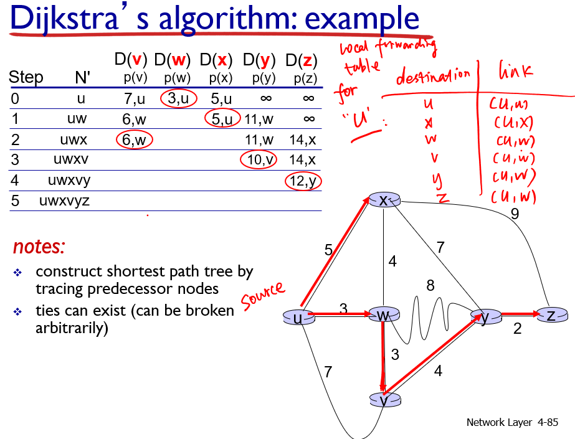

Distance Vector Algorithm/ Bellman-Ford: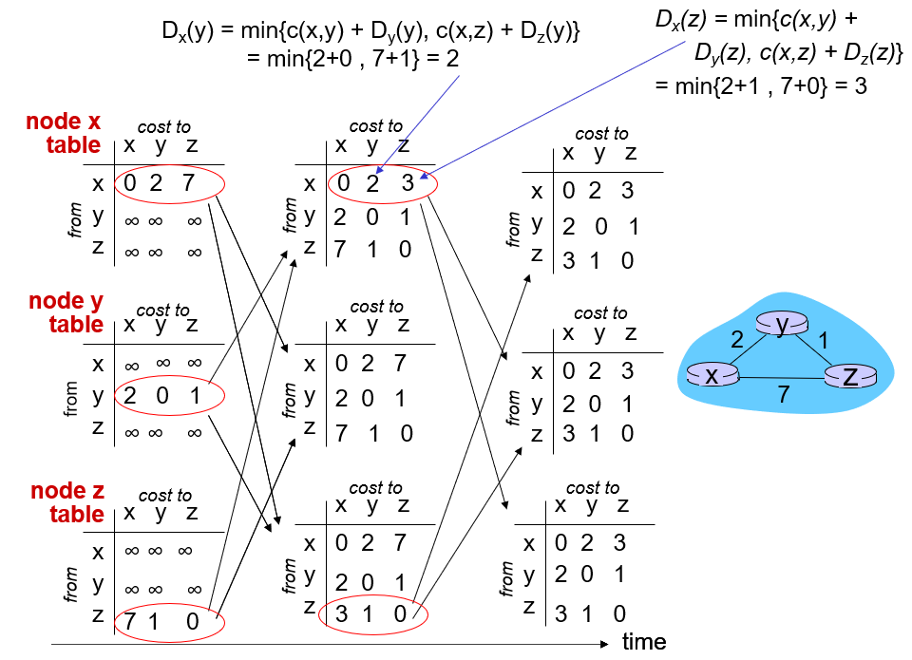

dx(y) := cost of least-cost path from x to y

= dx(y) = minv {c(x,v) + dv(y) },

minv is the total taken over all neighbors v of x,

c(x,v) = cost to neighbor v

dv(y) = cost from neighbor v to destination (y)

Hierarchical routing - aggregates routers into regions, “autonomous systems” (AS)Intra-as routing - Tasks and protocol within an AS, can be different to another AS Inter-as routing - Tasks and protocols outside of AS

4.6 routing in the internet

OSPF(Open shortest path first) - opens publicly available paths and floods advertisement to entire AS.uses link state algorithm, Intra-as routing.

BGP(Border Gateway Protocol) - the de facto inter-domain routing protocol,allows subnet to advertise its existence to rest of Internet, inter-as routing. Two types of BGP -

eBGP, used to obtain subnet reachability information from neighboring ASs, iBGP used to propagate reachability information to all AS-internal routers.

BGP route selection rules - The router may learn about more than one route to destination AS, selects route based on

1.local preference value attribute, policy decision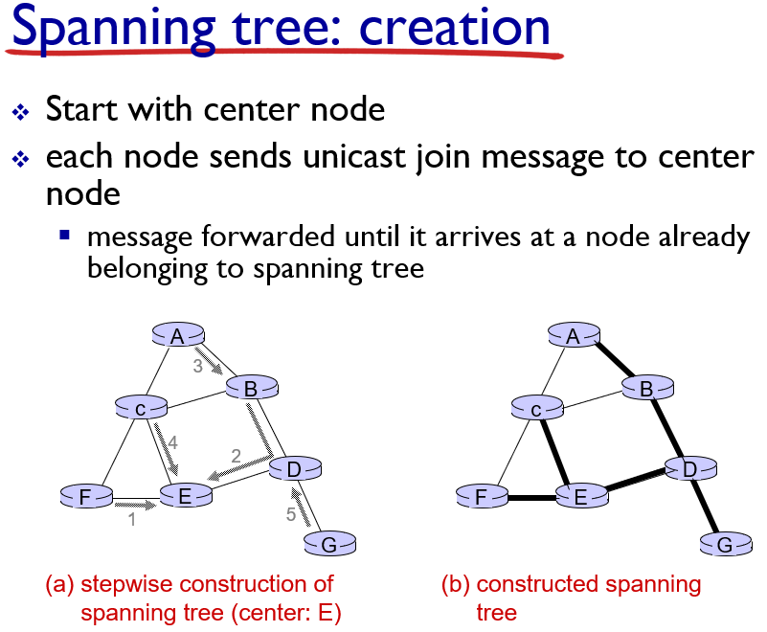

2. Shortest AS-path 3. Closest next-HOP router: hot potato routing. 4. Additional criteria.

4.7 Broadcast

Spanning tree is a method of how to prevent redundant packets received by node